**BRIDGING THE GAP: ACCESS TO EDUCATION IN RURAL AFRICA**

**Introduction**

In the heart of rural Africa, the quest for education is a journey of resilience and hope, despite numerous challenges. This photographic essay explores the various aspects of access to education in these communities, highlighting the determination of students and the innovative efforts to bridge the educational divide.

**1. The Journey to School**

For many children in rural Africa, the journey to school is a daily challenge. Long distances and difficult terrain are just the beginning. Without adequate transportation, children often walk several miles, facing potential hazards along the way. Yet, their determination to learn drives them forward each day.



**2. The School Environment**

Schools in rural areas often operate under challenging conditions. Many lack basic infrastructure, with classes held under trees or in dilapidated buildings. The lack of proper facilities hampers the learning experience, but it also highlights the resourcefulness of communities that make do with what they have.

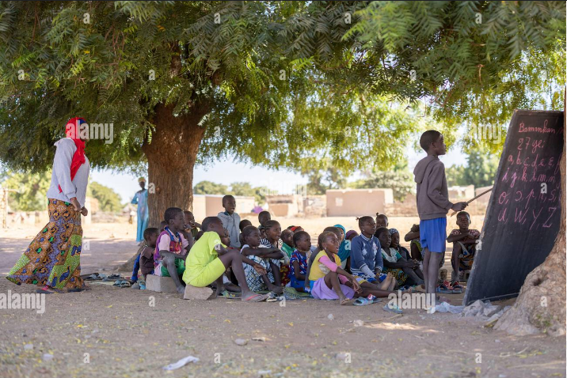

**3. Learning Materials**

Educational materials are scarce in many rural schools. Students frequently share textbooks, and the few available resources are often outdated and worn out. Despite these limitations, students and teachers find ways to maximize their use, demonstrating an admirable commitment to education.



**4. Teacher Shortage**

One of the most significant challenges is the shortage of qualified teachers. Overcrowded classrooms are common, with one teacher responsible for many students. This lack of individual attention can impede learning, but it also showcases the dedication of educators who strive to make a difference.

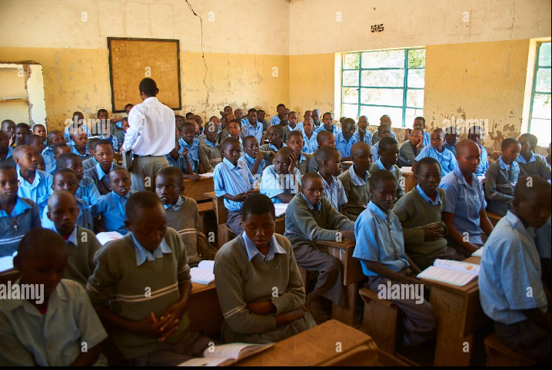

**5. Impact on Students**

The impact of these challenges on students is profound. Yet, many show remarkable resilience and a strong desire to learn. Their faces reflect a spectrum of emotions from determination to frustration but their commitment to education remains unwavering.



**6. Community Efforts**

Communities play a crucial role in supporting education. They often come together to build or repair school facilities, demonstrating the value they place on education. These collective efforts are a testament to the community’s commitment to providing better opportunities for their children.

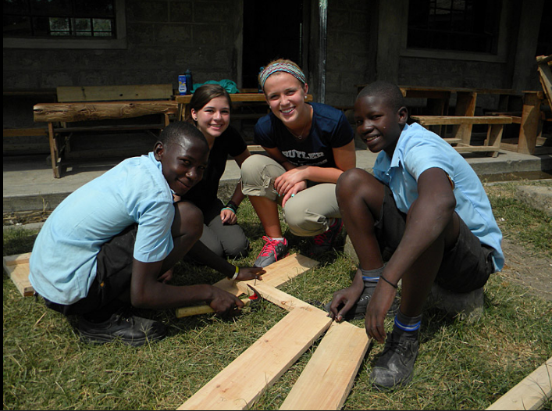

**7. Innovative Solutions**

Innovation is key to overcoming the educational challenges in rural Africa. Mobile libraries bring books to remote areas, solar-powered classrooms ensure learning can continue without electricity, and e-learning initiatives open up new opportunities for students. These solutions are helping to bridge the gap and provide quality education.

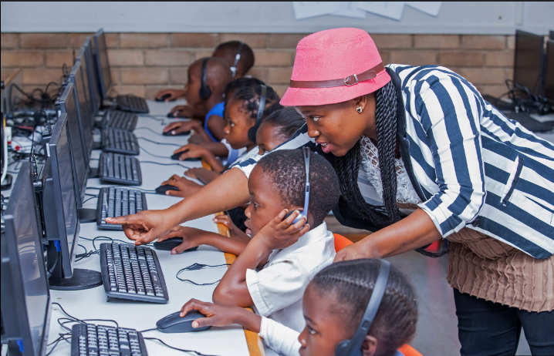

**8. Success Stories**

Despite the obstacles, success stories abound. Many students from rural schools go on to attend universities or pursue professional careers. These stories of achievement highlight the transformative power of education and the potential within every student.



**Conclusion**

The future of education in rural Africa holds promise. With continued support and innovative approaches, more children will have the opportunity to learn and thrive. This photographic essay underscores the importance of investing in education and the remarkable potential of students in rural Africa. 